TheFibers
C R E AT I V E F I B E R S

User Manual

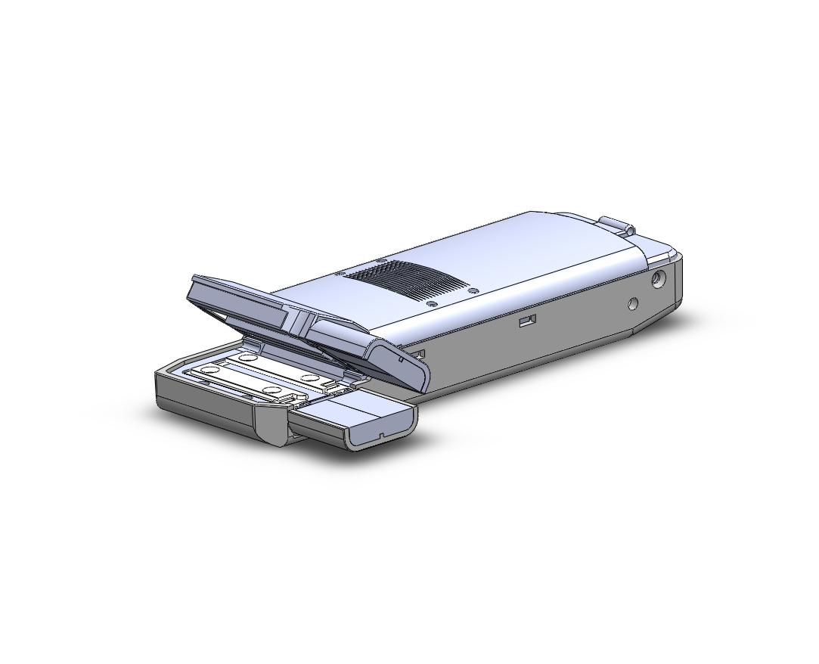
FTSTM
Fiber Optic Thermal Stripper

INTRODUCE
FTSTM is very usefully device to strip coated fiber in FTTH/FTTx in field. You can strip your optical fiber by just one hand operating easily. Don’t need put the Stripper on floor for stripping any more! Don’t need bow your waist for stripping any more!

AVAIABLE APPLICATIONS
▪ Fiber To The Home (FTTH) and FTTx
▪ Fiber Optic Installation and Networks
▪ Fiber Optic Product Manufacturers
▪ Fiber Optic Components Production

STANDARD PACKAGE
a. FTS (included Battery)
b. Typical 24-pin Charger
c. Necklace
d. Brush
e. Manual

WARRANTY
FTSTM you bought is passed our all inspection and then is shipped to our customer. TheFibers give you a warranty for one year from the buying date. During the warranty period, the returned product by freight prepaid from the customer, TheFibers will provide repair and replacement for any defective product without additional charge which is needed to repair or replacement.

However the following are expressly NOT COVERED under warranty:
▪ Any loss, damage by un-approved Battery and AC Adaptor
▪ In case the serial and warranty sticker is removed
▪ Failure to use products under abnormal operating conditions
▪ Any loss, damage by user fault
▪ Any damage by disassembly without permission

KEY FEATURES
• Very usefully device to strip coated fiber in FTTH
• Hand-held type Thermal Stripper
• Easy One Hand Operating
• Economic Price but High Strip-Quality
• No Fiber Scratch/Crack after stripping
• Safety Heating Controller
• High Performance Stripping Structure
• Available for Single Fiber and Ribbon Fiber
• Typical cell phone travel charger
• Anti-slip Grip Design
• RoHS complied

HARDWARE SPECIFICATIONS
Part Number | FTS-900 FTS-250 FTS-RF
Applicable Fiber Type | 900um 250um 12-Ribbon Fiber
Coating Range Stripped | 900/250um 250um 400/250um
Heating Range | Ceramic Heater 70~140 ℃ (max)
Fiber Strip Length (max) | 35mm
Stripping Time | 1 ~ 2 sec. (max)
Input | DC 4.2V 750mA TTA 24-Pin Charger
Battery | 3.7V 2200mA  Rechargeable Lithium Ion Battery
Battery Running Time | Approx. 4 hours
Power of Charger | 110/220V@50/60Hz
Charging Time | 4 hours
Dimension | 150(l) x 25/45(w) x 15(t) mm
Weight | 150g (including Battery)

PRODUCT OVERVIEW

- Hang Necklace on FTS and ready Brush.

- You can use 2 type for power; one is Battery and the other is Charger. Battery is used when you use it in field without power source. Charger is used when you work in factory or some place to get outlet. If you choose way to supply power, see next step following your power type

3. Battery type
We provide rechargeable 3.7V, 2200mA, Lithium Ion Battery which is included in FTS. You can work over 4 hours by the battery which is full. You can always check battery status by LED lamp on FTS. The lamp provides battery status by changing color. The lamp show GREEN when the battery is full. But the lamp changes RED when the battery reaches low. You can see the how to charge more detail next step.

To replace of Battery, loosen the side screws and push the side hooks by pin and open the upper parts and replace new Battery.
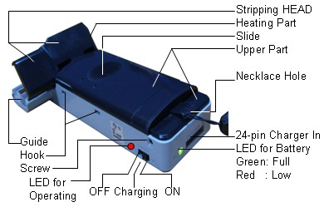

[Product Overview]

4. Charger type
We also provide TTA 24-pin Charger which is typical cell phone charger. The required electric Power of Charger is 110/220V@50/60Hz. You have to plug the 24-pin jack into FTS to charge.

5. Please see the switch on the side of FTS. The switch is for controlling power on-off. And the switch has another function. If the switch is positioned power on to work with Charger, you can also charge battery at same time. When the switch turns power on, the LED lamp is GREEN in case of full battery or use with Charger.
HOW TO STRIP

Operation
- Switch ON and Warm Up : To strip the coating materials well, FTS should be heated enoughly in advance and Warm Up Time is recommended over 1~2 minutes. After 1~2 min, if side LED is light, it means operating condition. We recommend to strip 900um fiber by FTS-900, 250um fiber by FTS-250 and 12-Ribbon Fiber by FTS-RF to get satisfied stripping quality. Because each model was setted in factory by the most suitable conditions per each cable like Shape of Blade and Guide. These conditions couldn’t be changed or controlled by enduser direct. Just you can control the Temperature Setting according to your cable material condition.
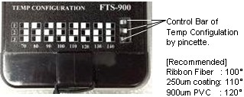

- Please keep clean and care Guide and Heating Parts which are most important parts to do the best stripping. Sometimes some coating residues are remained on the heating parts after stripping. The residues of coating materials after stripping should be brushed or blowing by mouth.

- Catch FTS by right-hand. Pull SLIDE and open the stripping HEAD. Put Fiber on the GUIDE supported by two fingers of left-hand after fitted a scale according to your stripping length. Strip after 1~2 seconds. Push SLIDE or HEAD by thumb of right-hand during stripping.
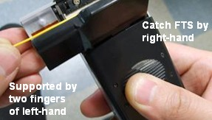

Important

Put Fiber on the GUIDE supported by two fingers of left-hand
We strongly recommend to support GUIDE by two fingers
when you put the Fiber to avoid hand-tremble.

Push SLIDE or press HEAD during stripping
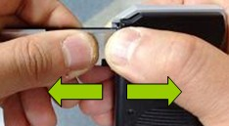
You have to push SLIDE or press HEAD (see below picture) during stripping to prevent shake of the Fiber which is a reason of stripping error.

Charging Battery

- Connect the 24-pin jack of the Charger into FTS to charge. And move the Switch to CHARGE ON (center position).
- LED is RED at the start time. But when battery is full, you
can see LED is GREEN and it takes about 4 hours.
- When Battery was fully discharged, but if you want to use
FTS with Charger, please use it at least after 30 minutes charging.
TheFibers Inc.
A-1109 Keumkang Penterium IT Tower
282 Hagui-ro, Anyang-City, Korea
Tel: +82-31-381-6108
Fax: +82-31-381-6109
sales@thefibers.com
www.thefibers.com

